**GOVERNMENT COLLEGE OF ENGINEERING [IRTT]**

**ERODE: 638 316**



**Electronics and Communication Engineering**

**NAAN MUDHALVAN**

**DIGITAL MARKETING**

**ASSIGNMENT**

NM ID: 7E89DF73D2A8B93B0E54BDE419176721

NAME: SANMITHA S

*BRAND NAME: OFF-WHITE COLOURS*

*CATEGORY: CLOTHING BRAND*

1.Create a blog or website using Blogspot and WordPress. Customize the theme design and post new article with 500 words.

Link: Blog using Blogspot

<https://off-white26.blogspot.com/2023/08/off-white-colours-apparel-clothing.html>

Screenshot:

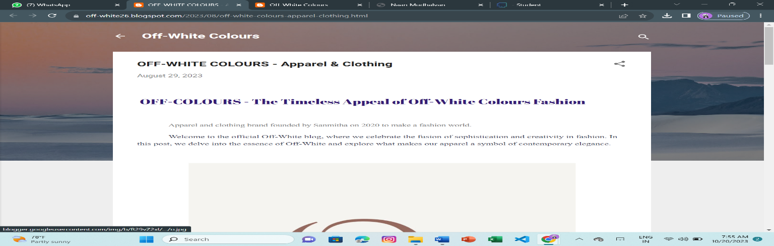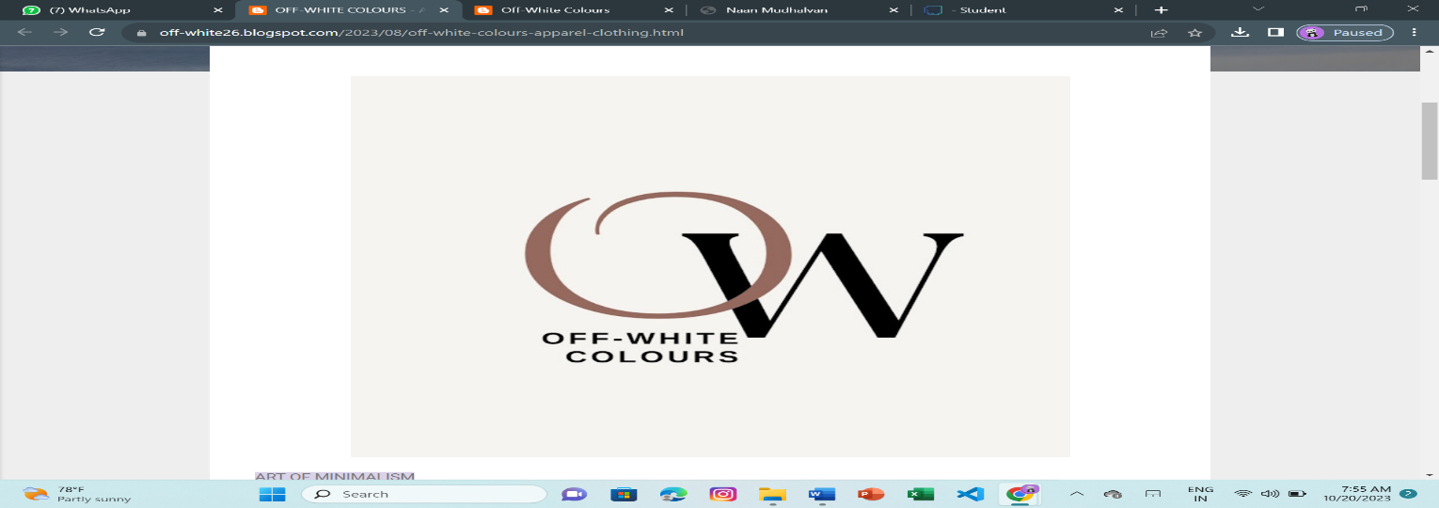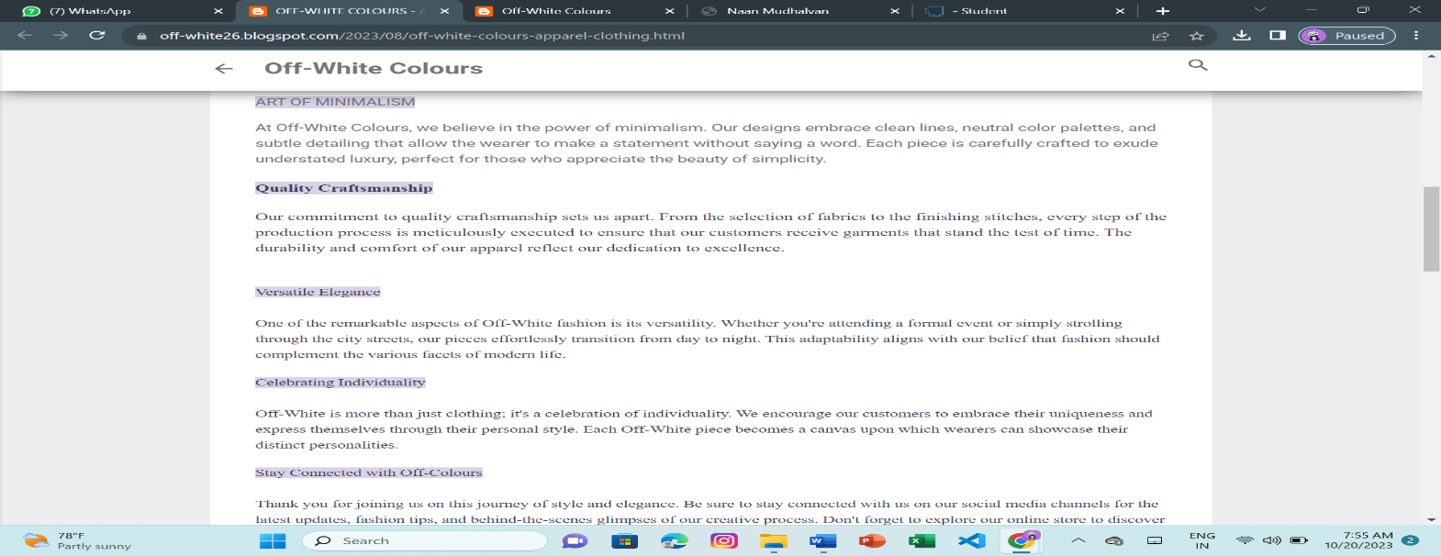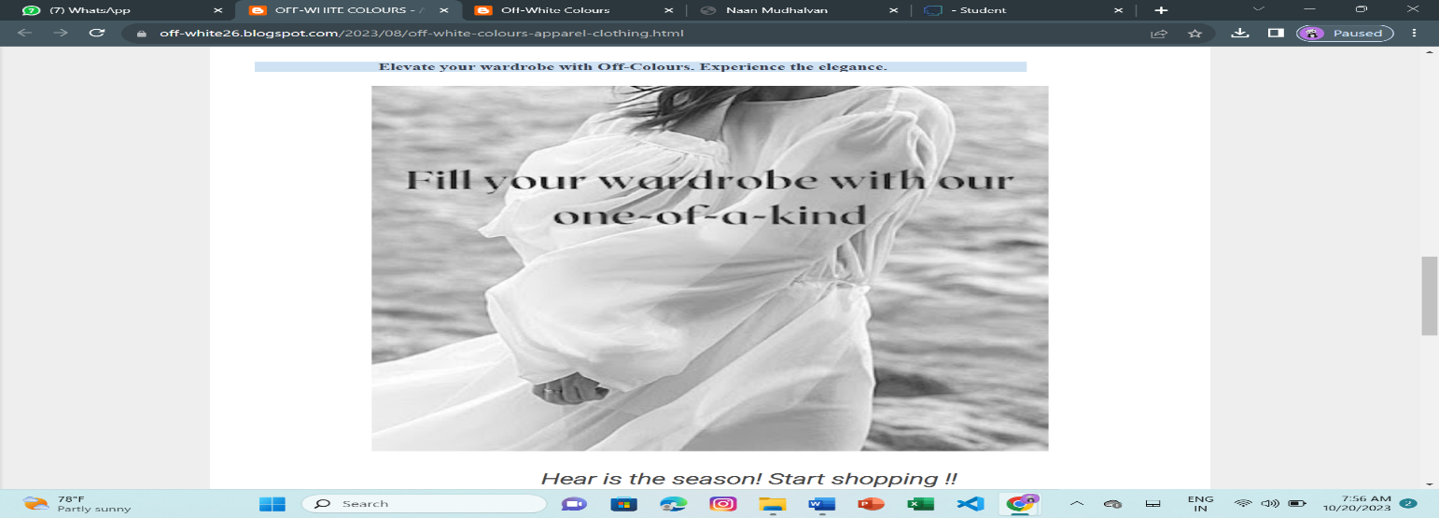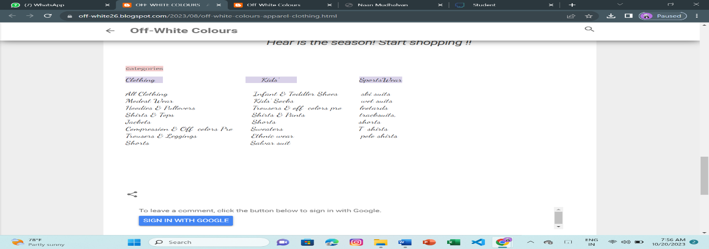

2.Create a New Facebook Business Page and post one social media poster for your brand.

Link: Facebook business page

<https://www.facebook.com/profile.php?id=61550568444663&mibextid=ZbWKwL>

Screen shot: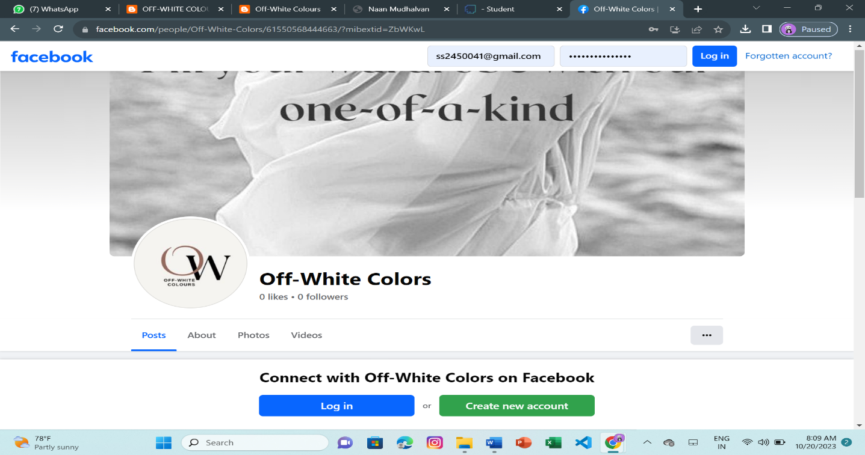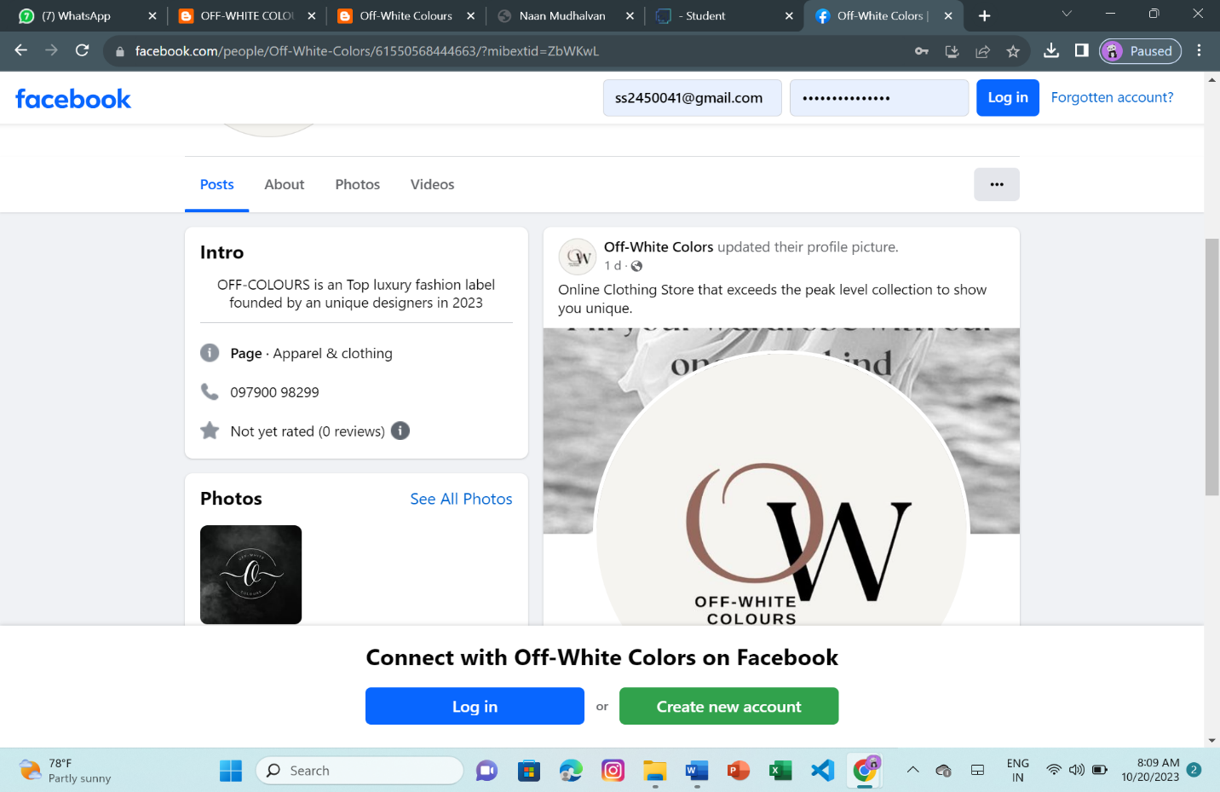

3.Create and design a social media advertisement poster using canva.

Link: Social media advertisement using canva

<https://off-white26.blogspot.com/2023/08/infographic-fall-fashion.html>

Screenshot: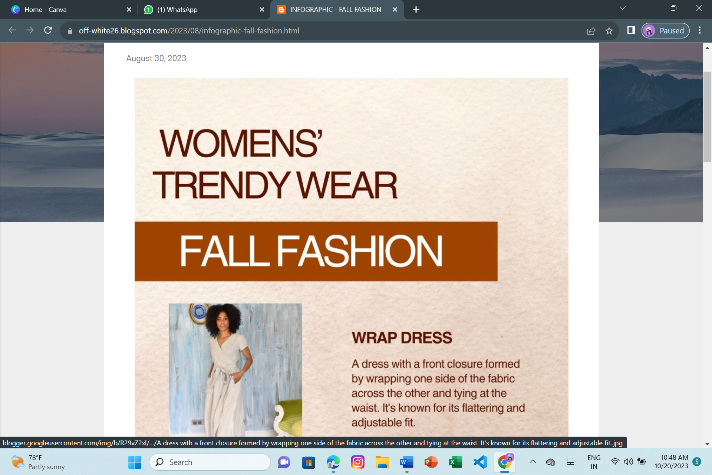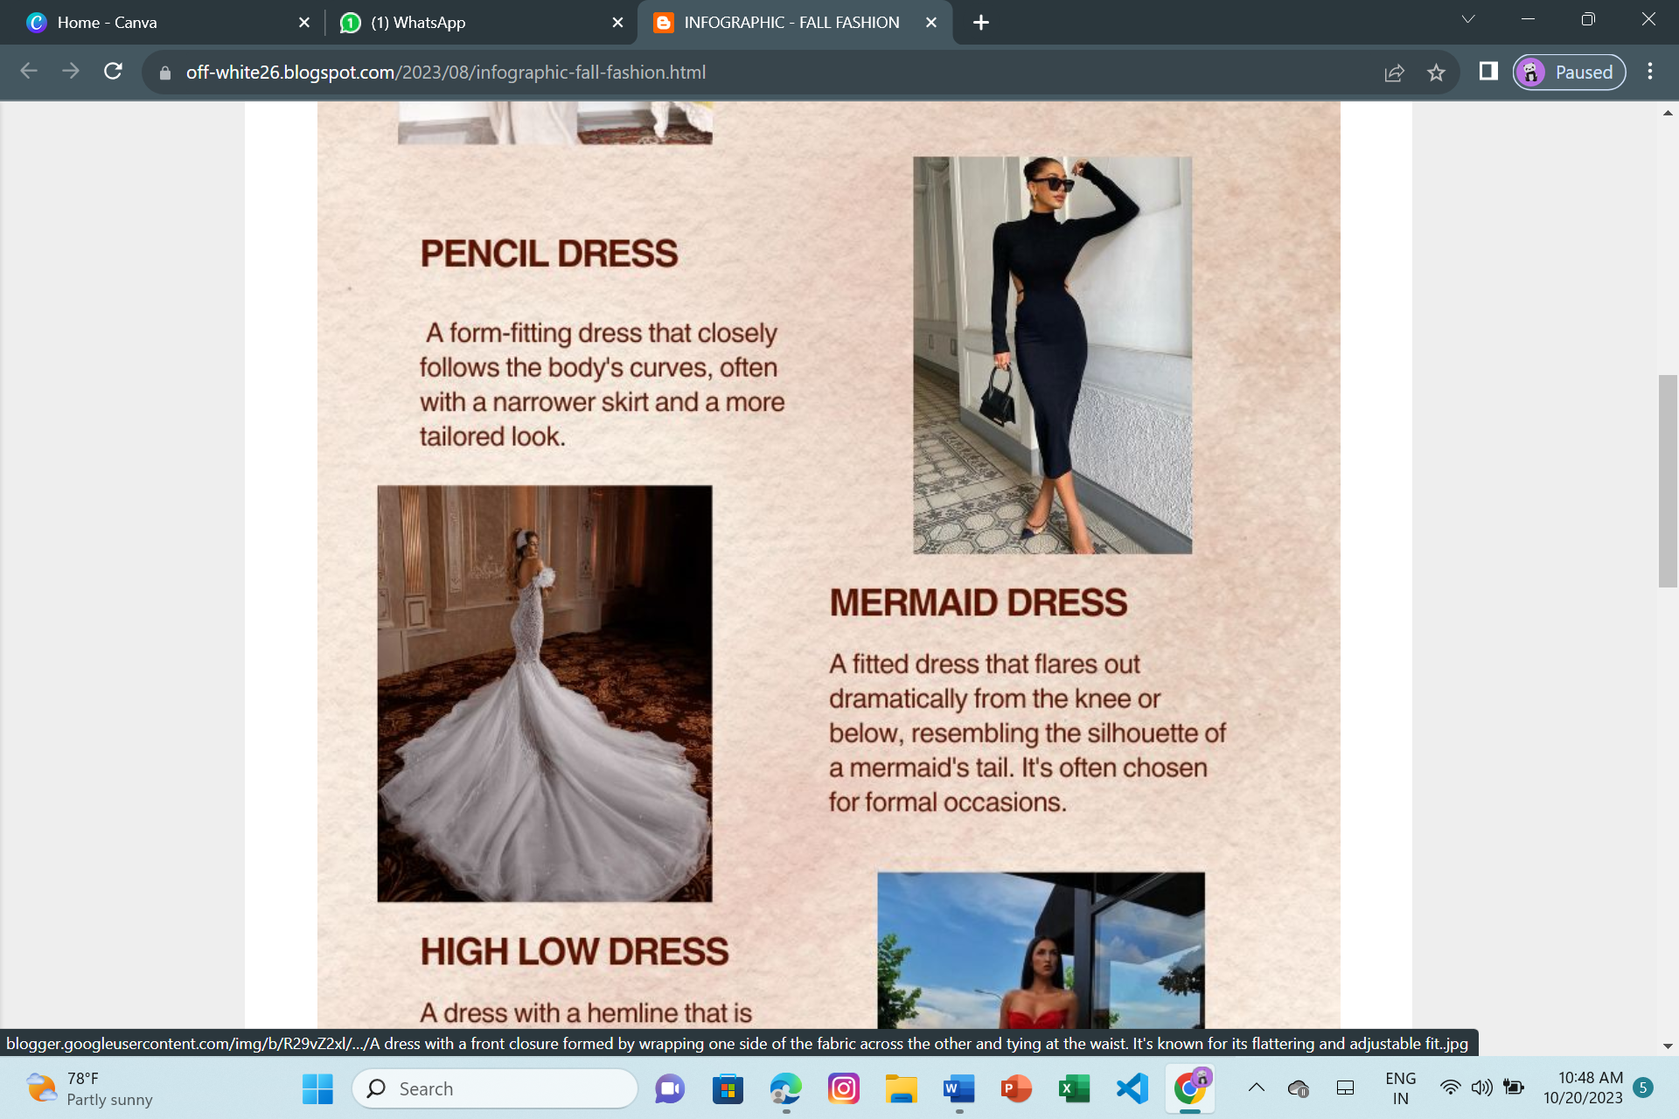

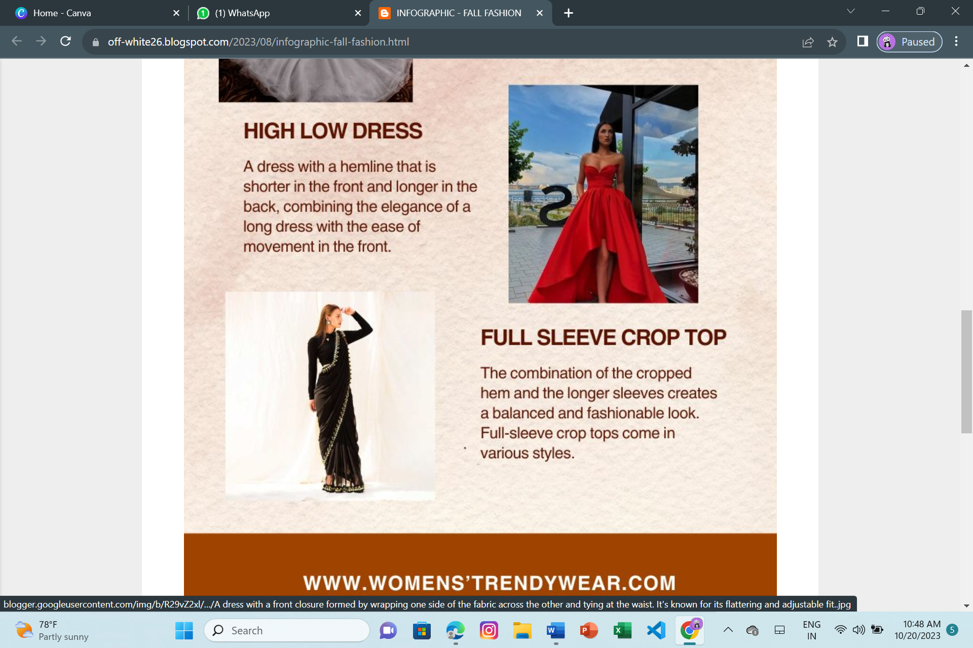

4.Create email newsletter design using MailChimp or canva tool.

Link: Email newsletter design using canva

<https://off-white26.blogspot.com/2023/08/email-newsletter-off-white-colours.html>

screenshot: